Fumida Iida write-up: Feasibility study of “robotisation” toward intelligent vegetable harvesting (vege-bot)

Fruit and vegetables require careful handling from planting through to harvesting to ensure they meet consumer expectations. Farmers rely on human field labourers because handling requires many sensitive processes, such as accurate cutting of product from the field and assessing the product for any damage. Demand for labourers is high however, and so automation is one possible solution.

Dr Fumiya Iida and his group from the Department of Engineering have been developing a robot for harvesting lettuce – a “vege-bot”. The vege-bot will be equipped with artificial hands and various sensors in order to be able to identify mature lettuces and harvest them appropriately.

“Humans are able to understand and carry out highly “intelligent” processes when it comes to harvesting,” says Fumiya. “We are hoping our robotics technology will be able to do this too.”

The BBSRC Impact Acceleration Account pump-prime funding has allowed Fumiya and his team to conduct a feasibility study in partnership with G’s Growers Ltd. As the largest provider of lettuce in the UK, automation is something that’s been on their minds.

“We’re very reliant on people which is not ideal as fewer and fewer people want to work as farm labourers,” says John Currah, the Corporate Development Director for G’s. “The time is right for a new technology.”

The partnership meant that from initial tests in the lab, the group moved on to testing the vege-bot “Baxter” on lettuce fields at G’s. Field tests are vital to ensure that the vege-bot is able to cope with a more diverse and changing environment as compared with the lab. “In the field you are dealing with much more variability,” explains Fumiya.

The weekly field tests enabled the team to improve and adapt components of the vege-bot rapidly, for example optimising the cutting technology for the vege-bot hand so that the lettuce was harvested cleanly on a reliable basis. When asked what the most difficult part of the project was so far however, the answer was a little unexpected: logistics. “There are around 15 people involved, from manufacturing and software to our collaborators at G’s,” explains Fumiya. “Having everyone in coordination on the short time-frame has been a challenge.”

At the wrap-up workshop, Fumiya, his team and representatives from G’s evaluated the success of the project and discussed future directions. As a result of this study and one ensuing PhD studentship, Fumiya estimates that the vege-bot could be working in farms in as little as 3-5 years, whilst components of it will be used in other technologies much sooner. Following the success of the project, G’s Innovation Director Charlie Kisby is feeling optimistic:

“We hope by the end of that PhD we’ll have a working prototype and something potentially to build on for a commercial application.”

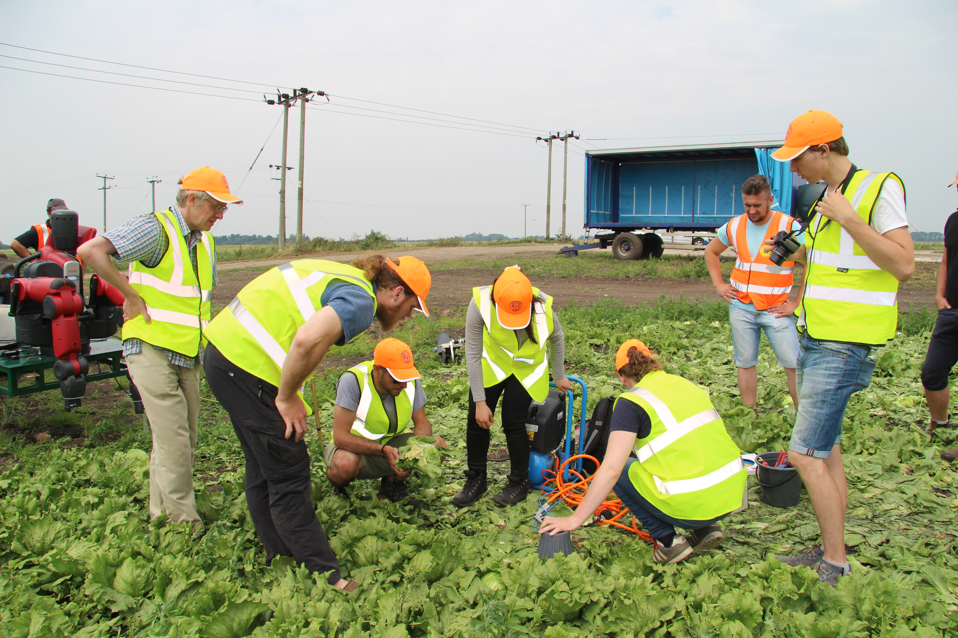
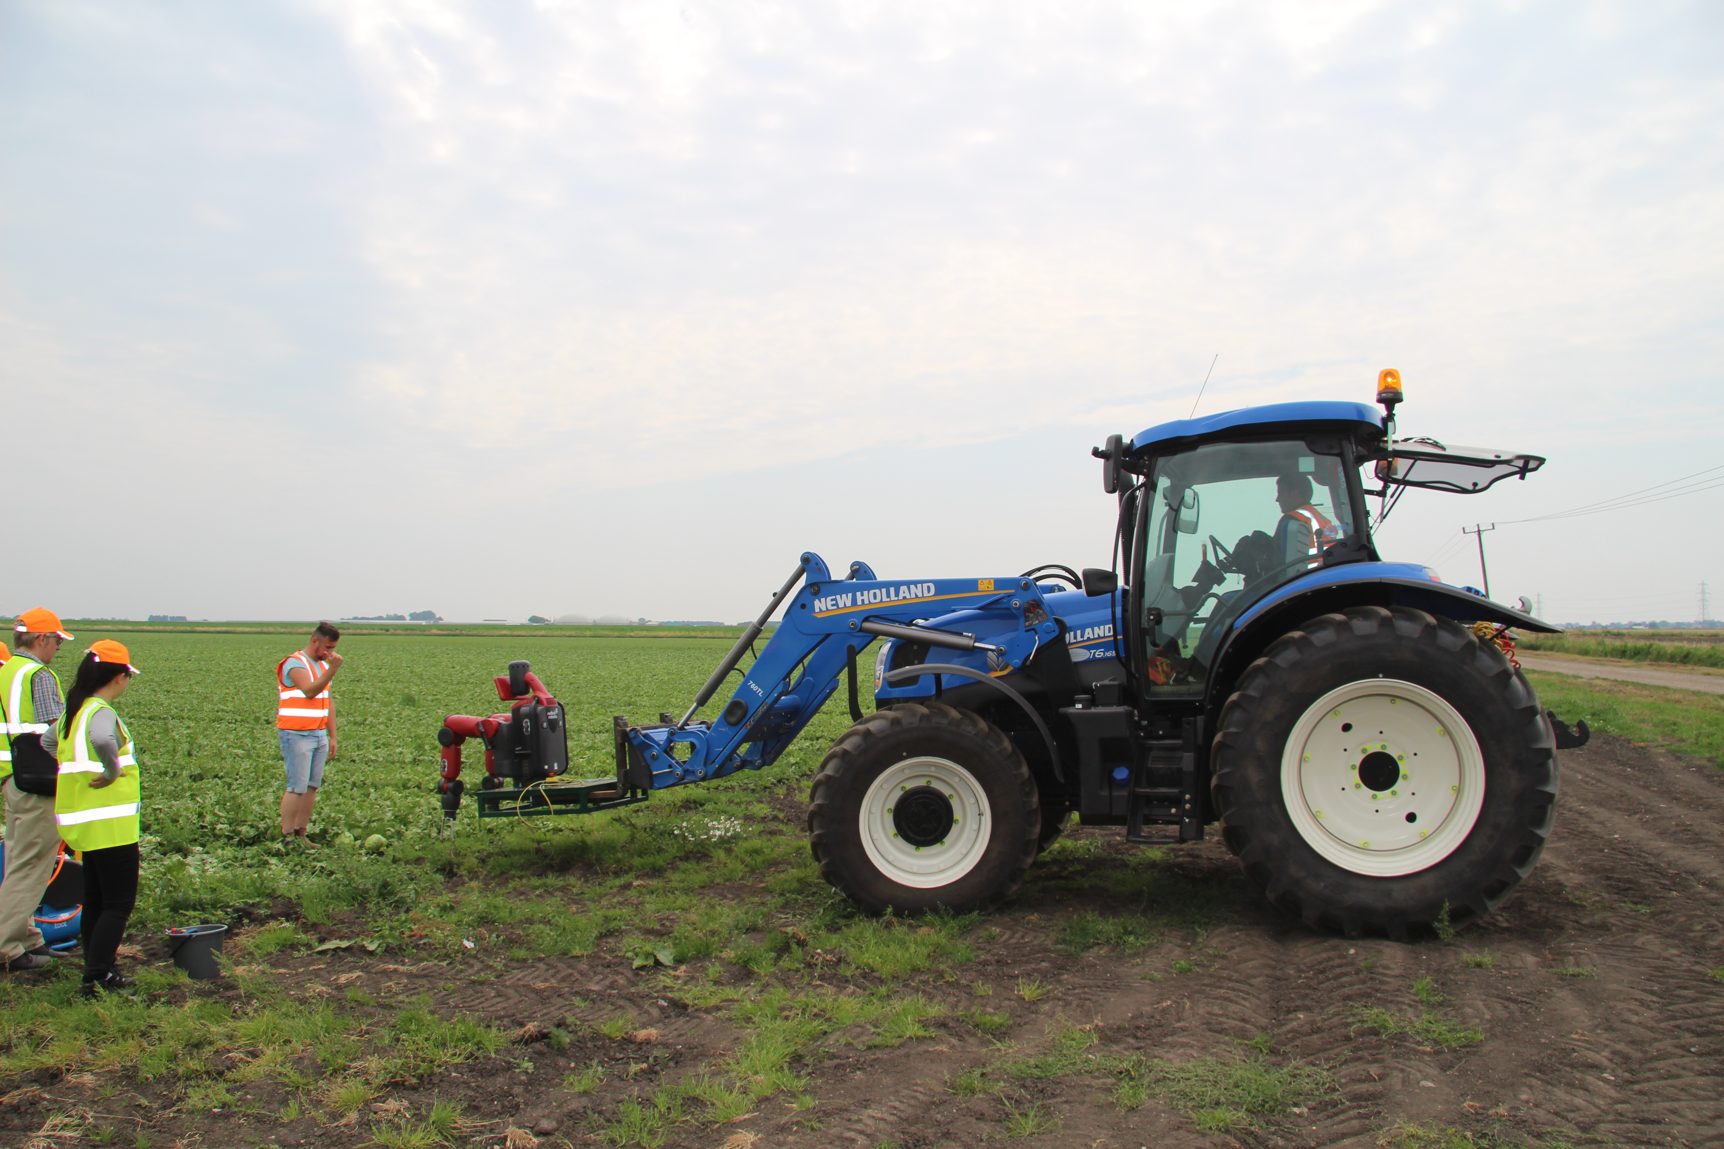
A forklift and tractor is used to move the vege-bot
Testing cutting mechanisms in the field

